Cityscape and Cycle Paths: Understanding Regional Disparities in US Bike-Sharing Systems
Myra Nguyen & Jaren Canty
In this analysis, we examine bike ridership data across the United States, sourced from the publicly available Docked Bikeshare Ridership by System, Year, and Month. This dataset contains detailed information on bike trips made across various cities, including key metrics such as trip counts, trip durations, system types, and geographical locations. Given the increasing popularity of bike-share systems as a sustainable and efficient mode of urban transportation, understanding ridership patterns is essential for improving system performance, ensuring equitable access, and informing urban planning decisions. The primary goal of this analysis is to explore these ridership patterns and identify insights related to system performance, trip durations, and seasonal variations in bike-share usage.
Our analysis is guided by several key research questions that aim to uncover deeper insights into bike-share usage across different regions. First, how does the density of bike-sharing systems and usage vary across different metropolitan areas in the United States? Second, is there a significant difference in the average trip duration between the four seasons (Winter, Spring, Summer, and Fall)? Lastly, how did the COVID-19 pandemic impact bike-sharing usage patterns in different cities and regions? These research questions help uncover key insights into bike-share usage by examining regional differences in system density, seasonal variations in trip duration, and the impact of the COVID-19 pandemic on ridership patterns. Together, they provide a deeper understanding of factors that influence bike-sharing trends across the United States.
To ensure that the data was suitable for addressing these questions, we began by reviewing and cleaning the original dataset using Python scripts and the Pandas library. We first streamlined the dataset by removing irrelevant columns such as geon, sysorder, and may_ind, focusing on key variables related to bike trips, system types, and geographic locations to better assess the density of bike-sharing systems across metropolitan areas. Next, we cleaned the sum_min (trip duration) and num_trip (number of trips) columns, addressing records where both values were zero, to ensure accurate analysis of seasonal variations in trip duration. Lastly, we utilized Pandas to identify and resolve anomalies, particularly those related to missing or incomplete data, which could have been impacted by the COVID-19 pandemic. This step ensured that the dataset was complete and reliable for examining its effects on bike-sharing usage.
After cleaning the data, we created a PostgreSQL database that included three key tables: the system table, the date table, and the fact ridership table. The system table captured details about the bike-sharing systems and their geographic locations, the date table recorded time-based dimensions for analysis, and the fact ridership table aggregated data on trips and their associated metrics. The cleaned dataset was then matched with the corresponding tables, and all relevant information was imported into PostgreSQL.
Additionally, since we aimed to focus on cities rather than specific bike-share companies, we simplified the system names during the import into Tableau. We created aliases for the sysname field, reducing it to represent only the city and state associated with each bike-sharing system. This adjustment allowed for a more streamlined and city-focused analysis, making it easier to compare ridership trends across different metropolitan areas. This structured and refined dataset now provides a robust foundation for comprehensive analysis, enabling insights into bike-share usage patterns across the United States.
With a robust and cleaned dataset prepared, we now turn to addressing the key research questions identified earlier. Using Tableau and Python, we created visualizations and conducted statistical tests to uncover trends and patterns in bike-share ridership. Each question is explored in detail below, with an explanation of the graph types, calculated fields, and statistical techniques used to support our findings.
To explore how bike-sharing systems and their usage vary across U.S. cities, we created a series of visualizations in Tableau. A symbol map (Figure 1) highlights hotspots for bike-sharing usage, with the size and color of the dots indicating the number of trips recorded in each city. Cities with higher trip volumes are represented by larger, more intensely colored dots, showcasing areas with significant bike-sharing adoption.

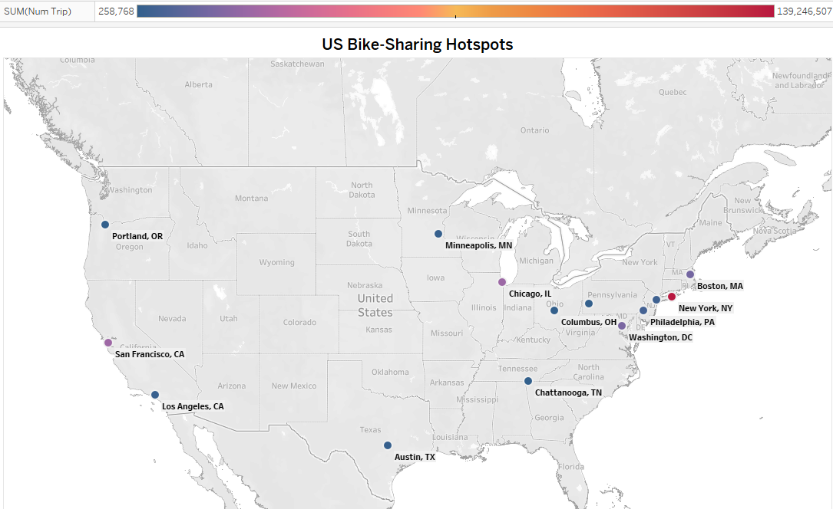

Figure 1 :Map of U.S. bike-sharing hotspots, with color intensity representing the number of trips. Darker colors indicate higher trip volumes in each city.

Upon analyzing the map, it becomes evident that bike-sharing systems and usage exhibit considerable variation across U.S. cities, as illustrated by a heat map visualization. This visual provides a breakdown of the cities with the highest and lowest amounts of bike-share usage, using color gradients to represent the number of riders. Cities with fewer than 10 million riders appear in cooler blue tones, while those with tens to hundreds of millions of users are marked in warmer purples and reds. These patterns reveal significant insights into how bike-sharing systems cater to diverse urban needs.
Cities like Columbus, OH, and Chattanooga, TN, represent hotspots with comparatively lower usage among bike-share cities. In Columbus, the CoGo bike-share system complements limited public transit options, offering residents a viable alternative for short trips. Similarly, Chattanooga’s bike paths and scenic routes attract users who prefer biking over public shuttles. Pittsburgh and Minneapolis stand out for their affordability and innovative mobility hubs, respectively, making biking an accessible and convenient mode of transportation for residents. Other cities, like Los Angeles and Austin, emphasize flexibility and scenic experiences, attracting tourists, students, and suburban commuters. These cities illustrate how bike-sharing systems can fill gaps in urban mobility or offer alternatives to traditional transportation.
On the other end of the spectrum, cities with the highest bike-share usage, such as New York City, Boston, and Washington, D.C., reflect the success of well-established programs like Citi Bike, Blue Bikes, and Capital Bike Share. These systems thrive in densely populated areas with robust infrastructure and high demand for quick, affordable transit options. For instance, New York City’s Citi Bike offers a practical alternative to subway travel, while San Francisco’s SFMTA provides an iconic ride over the Golden Gate Bridge. Chicago’s Divvy system similarly appeals to those seeking cost-effective ways to navigate the city without relying on crowded buses or trains.
Together, these insights highlight the regional differences in bike-sharing usage, driven by factors such as population density, transit infrastructure, scenic opportunities, and affordability. The heat map not only visualizes these disparities but also underscores the adaptability of bike-sharing systems to meet diverse urban transportation needs.
To evaluate if there is a significant difference in the average trip duration between the four seasons (Winter, Spring, Summer, and Fall), we first performed data preprocessing using Python. We loaded the dataset, sorted it by season, and calculated the average trip duration by dividing the total minutes by the number of trips. To ensure data quality, we removed rows with missing or infinite values and confirmed the data was in numeric format. We then grouped the data by season and ran an ANOVA test to assess whether the mean trip durations differed between the seasons.
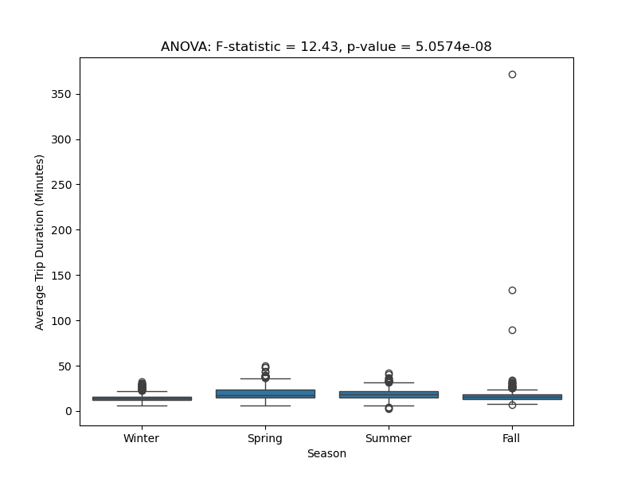
Following the ANOVA analysis, we visualized the results using a boxplot, which displays the distribution of average trip durations across the four seasons. The plot was annotated with the F-statistic and p-value from the ANOVA test to highlight the statistical significance of the findings. This visualization provided a clear comparison of trip durations across seasons and supported the interpretation of the ANOVA results (See Figure 2 below).

Figure 2: Boxplot of average trip durations by season, with ANOVA results.

The analysis revealed significant seasonal variations in bike-sharing trip durations. The ANOVA test showed statistically significant differences (p < 0.05 and p < 0.001) with a large F-statistic. Shorter winter trips, likely due to colder weather and fewer daylight hours, contrasted with longer trips in spring, summer, and fall, which may be linked to more favorable weather and increased outdoor activities. However, the data, covering 2019-2023, includes a period affected by the COVID-19 pandemic, which resulted in reduced ridership during colder winters. These anomalies suggest the need to interpret the findings with caution, especially regarding the winter data.
To understand how COVID-19 impacted bike-sharing usage across different cities, we analyzed annual ridership data using K-means clustering. This revealed three distinct groups: high-ridership cities like New York, which experienced a significant boom in usage, medium-ridership cities like Philadelphia and Washington D.C. with moderate usage, and low-ridership cities like Austin, Chattanooga, and Pittsburgh. Cities like Portland, Oregon, with less data and potentially lower initial usage, may not show clear trends or recovery patterns. These findings highlight the varying impacts of the pandemic on bike-sharing, influenced by factors like population density, bike infrastructure, and local policies (See Figure 3).
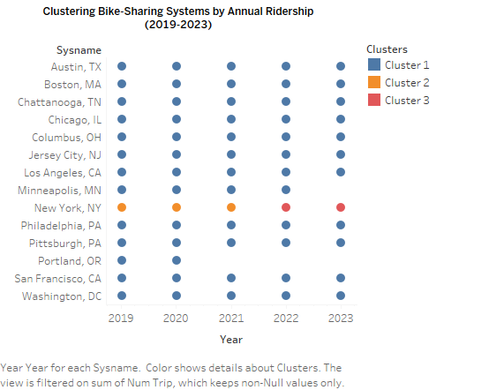

Figure 3: Bike-Sharing Usage Trends by City (2019-2023) illustrates how bike-sharing usage varied across different cities during the COVID-19 pandemic, with cities grouped according to their annual ridership patterns.
Our analysis of bike-sharing usage trends from 2019 to 2023 provides valuable insight into how the COVID-19 pandemic shaped urban transportation across various cities. By gathering and cleaning data on annual ridership, we identified significant shifts in usage patterns, addressing inconsistencies, normalizing the data, and factoring in external elements such as infrastructure changes and policy adjustments.
The findings reveal that while the pandemic initially led to a decline in bike-sharing usage, cities with established infrastructure or proactive policies were able to recover more quickly. Cities that adapted their services, offering greater flexibility or promoting bike-sharing as a safer alternative to public transit, saw a faster rebound. This variability in recovery rates underscores the importance of local context in shaping transportation system responses to global disruptions.
Cluster analysis further highlighted these differences, with most cities grouping into one cluster, except for New York City, which stood out due to its exceptional volume of bike share users—over 100 million more than the next highest city. This divergence emphasized how certain cities, particularly those with a robust infrastructure and high ridership, experienced a different trajectory. While it would have been interesting to exclude New York City from the visualization for a clearer look at the remaining cities, the hotspot heat map still provided a clear visual representation of which cities had higher bike-share usage and which had smaller, yet still significant, user bases.
These findings suggest that bike-sharing is not only a resilient solution during crises but also a key component of sustainable urban mobility. However, there are still many factors to explore, such as local economic conditions, urban density, and weather patterns, which could refine our understanding of bike-sharing adoption. Future research could also examine how other global disruptions, such as climate change or economic recessions, influence bike-sharing usage, helping to shape policy recommendations for more adaptable and resilient urban transportation systems.
The analysis of bike-sharing systems across the United States reveals significant regional differences in usage, shaped by factors such as infrastructure, urban density, and local policies. While the COVID-19 pandemic initially led to a decline in ridership, cities with well-established systems and proactive measures were able to recover more quickly. This highlights the importance of effective urban planning in fostering resilient transportation solutions. The findings also emphasize the role of bike-sharing in promoting sustainable urban mobility, offering valuable insights for future research. By considering additional factors like climate change and economic shifts, further exploration can refine our understanding of bike-share adoption and inform strategies for more adaptable, resilient transportation systems.

Reference Page
Bureau of Transportation Statistics. (September 6, 2024). Docked bikeshare ridership by system, year, and month. U.S. Department of Transportation. Retrieved November 20, 2024,
from https://data.bts.gov/Research-and-Statistics/Docked-Bikeshare-Ridership-by-System-Year-and-Mont/cvai-skrf/about_data

